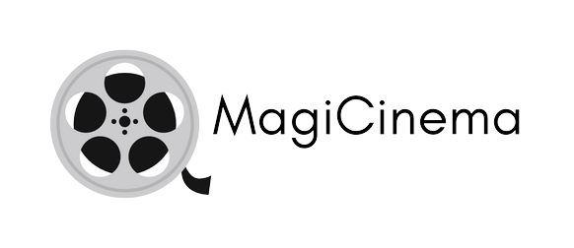

Данаил Вячеслав Фурника

Table of Contents

**Digitalization of Movie ticket booking system** 2

Project information and plan 2

Introduction 2

Realization 2

**Work plan** 3

Tasks for completion…………………………………………………………………………………………………………3

**Digitalization of Movie ticket booking system**

**Project Information**

* I recreated Movie ticket booking system using “raylib” and C++.

**Introduction**

|  |  |
| --- | --- |
| № | Introduction |
| 1 | **What is the product?**  The product is a Movie ticket booking app. C++, raylib and sqlite3 for the database. |
| 2 | **How can you access it?**  You can read about my work on GitHub and access my project’s repository files. |
| 3 | **What programs were used?**  I used GitHub for file management, Visual Studio for code editing, MS PowerPoint for my presentation, MS Word for the documentation. |

**Ways of Realization**

|  |  |
| --- | --- |
| № | How did we do it? |
| 1 | **Task Completion**  Every day I spent time thinking about what could be improved or make something new. Depending in the task difficulty I set to myself the time I spend on coding varies. |
| 2 | **Deadlines**  I set deadlines to myself every time I think of a task for myself. These deadlines are usually not longer than 1 week. If I don’t manage to finish the task I just continue on doing other tasks and if I have time, I would go back and edit the code/documentation. |

WORK PLAN

**Tasks for Completion**

|  |  |
| --- | --- |
| № | Task Breakdown |
| 1 | **Creating the main menu**  The main menu was created by me (the only backend developer). Allows for easier navigation through the app. |
| 2 | **Creating the filtering**  When you have entered the Movie window inside the app, you can filter what movies you want to watch by selecting what genre of movies you want to see and what day of the week are you able to watch the movie. |
| 3 | **Displaying the movie info**  After the movie list was sorted, all the movies that match the filter the user has set will show up. Specifically the movie poster, name, release date, genres. |
| 4 | **Book a ticket window button**  The user can find his button after the movie info in the Movies window. It redirects the user to a new window where he can book a ticket for a movie. |
| 5 | **Inside the Book a ticket window**  Four textboxes that await for user input show up. The textboxes are responsible for inputting the user’s: First name, last name, e-mail, phone number for the ticket booking system. |
| 6 | **Other features inside the Book a ticket window**  There are 2 other parameters that the user can input for his movie ticket. Showtime which allows the user to select when he wants to see the film and a selective menu for seats inside the theatre. |
| 7 | **Booking the ticket**  After the user submits all the info inputted, the data is stored in a database, where his ticket is saved. The selected seats for each ticket are unique and can be selected only by 1 user. |
| 10 | **Documentation**  I created the documentation using MS Word to summarise the application. |
| 11 | **Presentation**  The presentation was created by me to briefly explain the concept of the application. |